LAB 6.4
Task 1: Student Performance Evaluation System
Scenario:
You are building a simple academic management module for a university system where student performance needs to be evaluated automatically.
Prompt used:
# generate a python class name student with attributes name, roll_number and marks
# add a method to display the student details
# add a method that checks whether the students marks are above the class average and returns appropriate message take user input 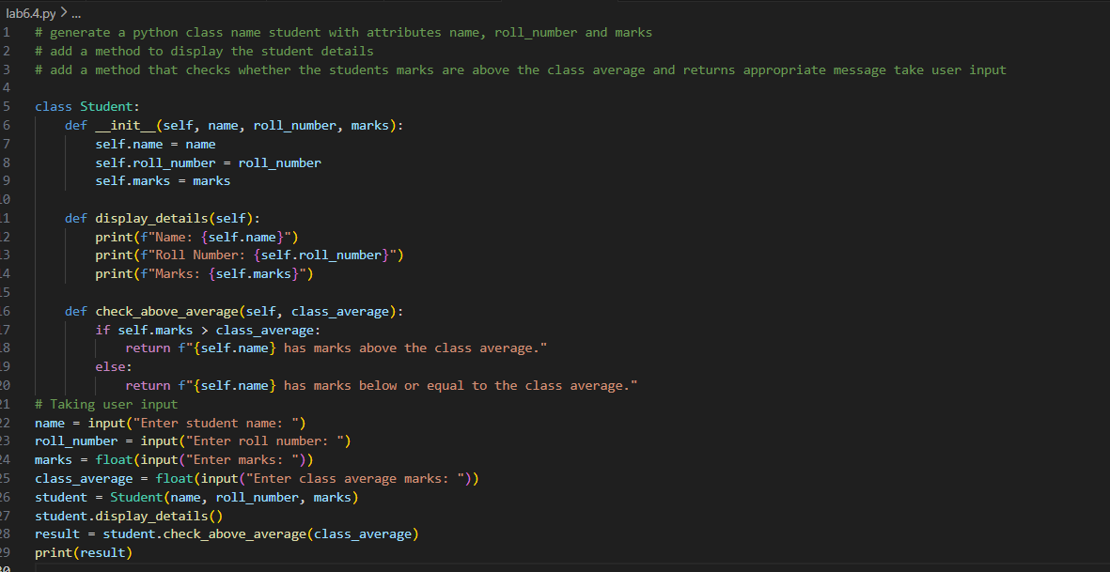
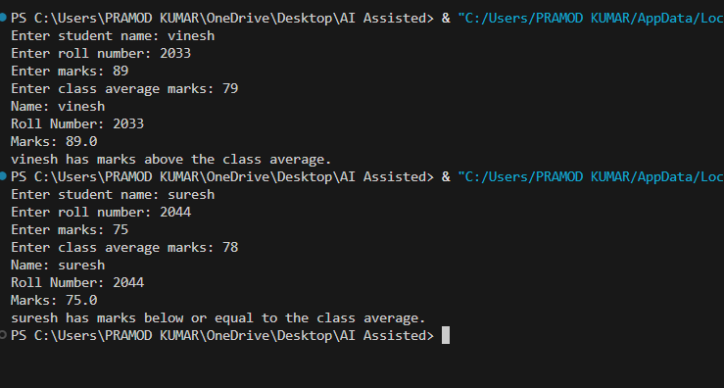

Task 2: Data Processing in a Monitoring System
Scenario:
You are working on a basic data monitoring script where sensor readings are collected as numbers. Only even readings need further processing.
Prompt used:
# generate a python function where sensor reading are collected as numbers
# identify the even number and calculate their square
# return the result in a tabular readable format take user input
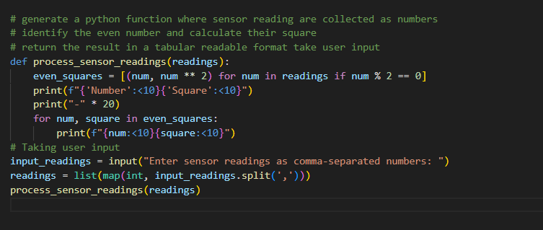
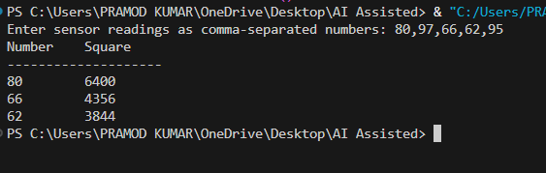

Task 3: Banking Transaction Simulation
Scenario: You are developing a basic banking module that handles deposits and withdrawals for customers.
Prompt used:
#generate a python function class named bankAccount with attributes acc_holder and balance
# add a method for depositing money and another method for withdrawing money
# and add another method for preventing withdrawls when the balance is insufficient take user input
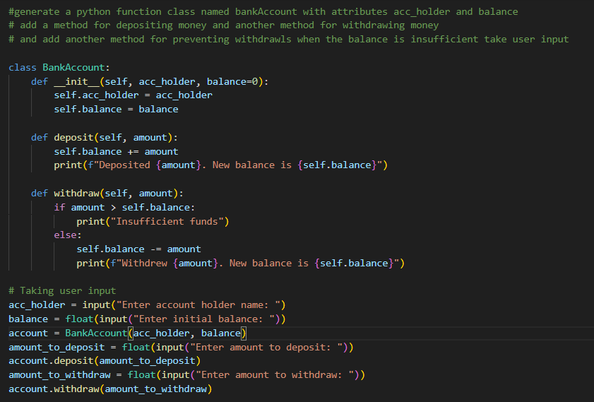
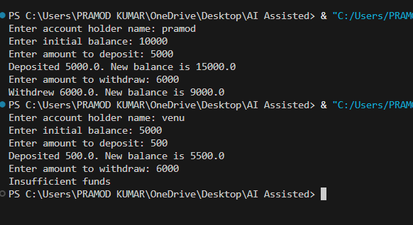

Task 4: Student Scholarship Eligibility Check
Scenario: A university wants to identify students eligible for a merit-based scholarship based on their scores
Prompt used:
# genetate a python function whether a sutdent is eligible for a scholarship based on their marks and attendance
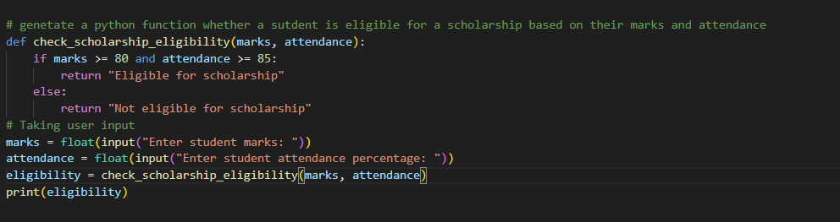
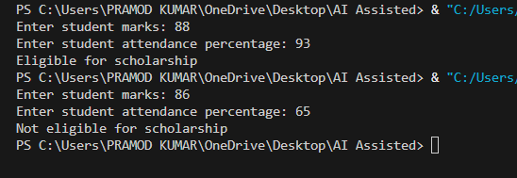

Task 5: Online Shopping Cart Module
Scenario:
You are designing a simplified shopping cart system for an e-commerce
website that supports item management and discount calculation.
Prompt used:
# Create a ShoppingCart class. The cart should store items in a list. Each item should have name, price, and quantity. Add a method to add an item to the cart. If the item already exists, update its quantity
#Add a method to remove an item from the cart by name. Add a method to calculate the total bill. Use a loop to calculate total price (price * quantity). Apply a conditional discount:
#If total exceeds 1000, apply a 10% discount. Otherwise, no discount
# Add a method to display cart items neatly
# Write sample code to demonstrate:
# - Adding items
# - Removing an item
# - Displaying total before and after discount
# take user input

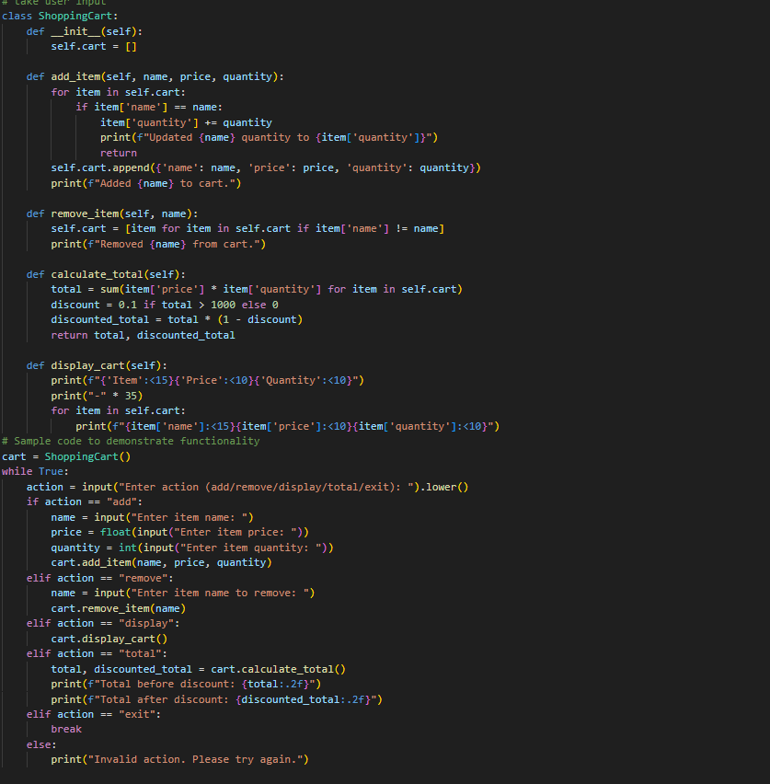
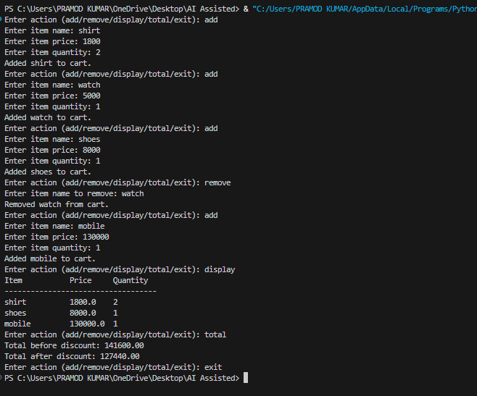
Code Explanation:
# 1. The first code snippet defines a `Student` class with attributes for name, roll number, and marks. It includes methods to display student details and check if the student's marks are above the class average.
# 2. The second code snippet processes sensor readings by identifying even numbers and calculating their squares. It displays the results in a tabular format.
# 3. The third code snippet defines a `BankAccount` class with methods for depositing and withdrawing money, including a check for insufficient funds.
# 4. The fourth code snippet checks if a student is eligible for a scholarship based on their marks and attendance percentage.
# 5. The fifth code snippet implements a `ShoppingCart` class that allows adding and removing items, calculating the total bill with discounts, and displaying cart items in a formatted manner. It includes a sample interactive loop for user input to demonstrate its functionality.

